In computer science, divide and conquer is an algorithm design paradigm. A divide-and-conquer algorithm recursively breaks down a problem into two or more sub-problems of the same or related type, until these become simple enough to be solved directly. The solutions to the sub-problems are then combined to give a solution to the original problem.

# Divide and conquer steps:

1. **Divide** the problem into a number of subproblems that are smaller instances of the same problem
2. **Conquer** the subproblems by solving them recursively
3. **Combine** the solutions to the subproblems into the solution for the original problem
4. The **base case** for the recursion is subproblems of constant size

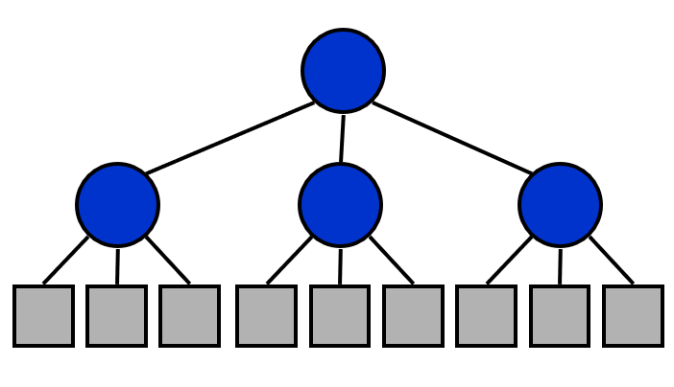

# Practice problems:

**Instructions:**

1. Do not adopt unfair means. **10 marks will be deducted from the final marks for adopting unfair means**.
2. No more than 40% marks for uncompilable codes.

## 1. Find the max and min element of an array.

**For loop version:**

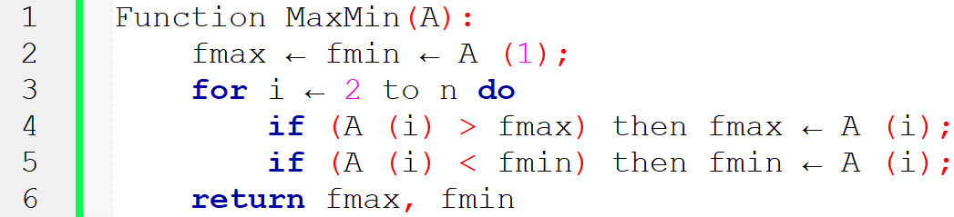

**Divide and Conquer version: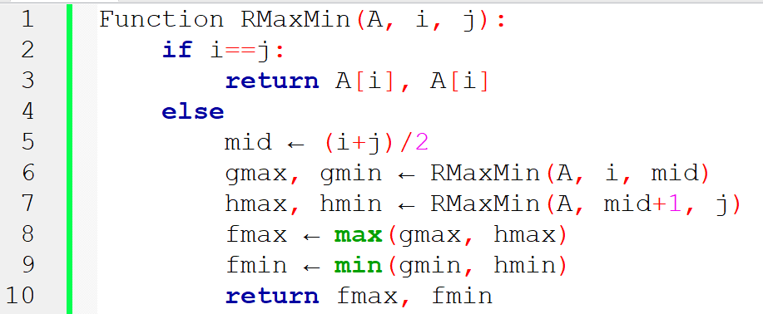**

**Recursion Tree:**

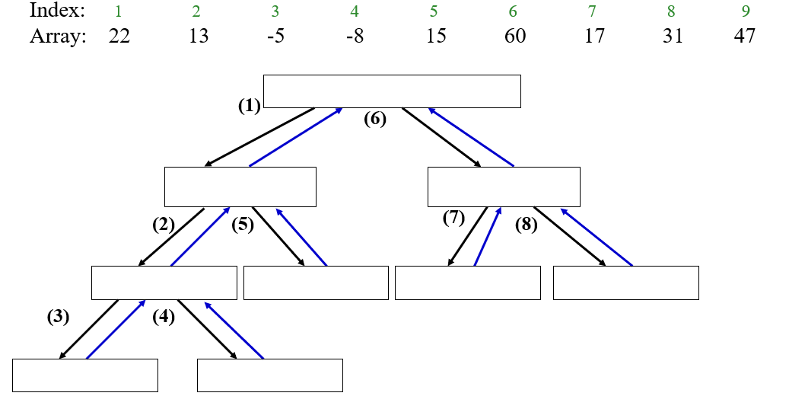

## 2. X^Y

**Hint:**

$$3^{100} = 3^{50} . 3^{50}=(3^{\frac{100}{2}}).(3^{\frac{100}{2}})$$

$$3^{50} = 3^{25}. 3^{25}$$

$$3^{25} = 3^{12} . 3^{12} . 3$$

$$3^{12} = 3^{6}. 3^{6}$$

$$3^{6} = 3^{3}. 3^{3}$$

$$3^{3} = 3^{1} . 3^{1} . 3$$

$$3^{1} = 3^{0}. 3^{0} . 3$$

## 3. Merge sort

|  |  |
| --- | --- |
| merge_sort_2 |  |

## 4. Count Inversion

<https://www.cp.eng.chula.ac.th/~prabhas//teaching/algo/algo2008/count-inv.htm>

The sequence 2, 4, 1, 3, 5 has three inversions (2,1), (4,1), (4,3).

The idea is similar to "merge" in merge-sort. Merge two sorted lists into one output list, but we also count the inversion.

* divide: size of sequence n to two lists of size n/2
* conquer: count recursively two lists
* combine:  this is a trick part (to do it in linear time)

## 5. Quick Sort

The quick sort uses divide and conquer just like merge sort but without using additional storage.

The steps are:

1. Select an element q, called a pivot, from the array. In this algorithm we have chosen the last index as the pivot.
2. The PARTITION function finds the location of the pivot in such a way that all the elements smaller than the pivot is on the left side and all the element on the right-hand side of the pivot is greater in value. (Items with equal values can go either way).
3. Recursively call the QUICKSORT function which perform quicksort on the array on the left side of the pivot and then on the array on the right side, thus dividing the task into sub tasks. This is carried out until the arrays can no longer be split.

Implement Quick sort algorithm. The pseudo code is given below:

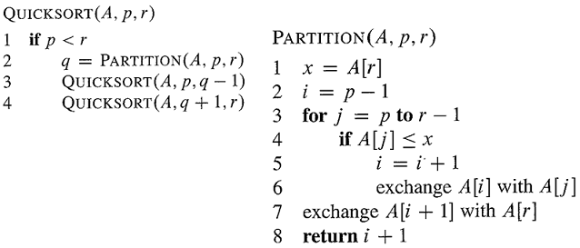

## 6. Binary Search

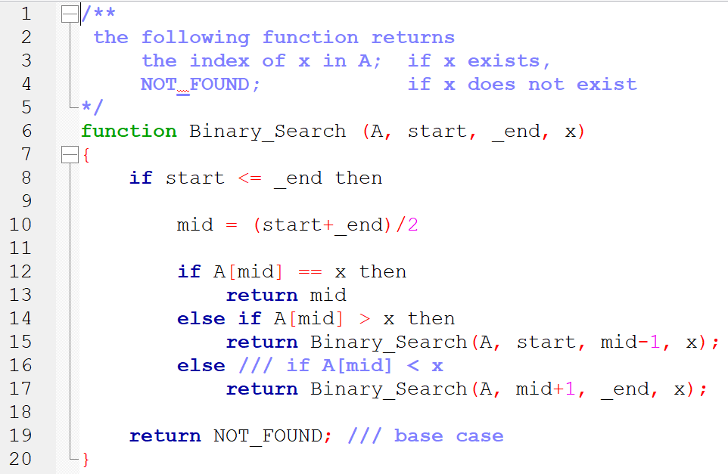

|  |  |
| --- | --- |
| **Sample Input** | **Sample Output** |
| Number of Elements: 5  Enter elements: 3 4 5 7 2  Key: 4 | 4 found in index 1 |
| Number of Elements: 5  Enter elements: 3 4 5 7 2  Key: 14 | 14 not found |

## 7.

Write a function print\_odd using divide-and-conquer algorithm to print the odd numbers of an array of n integers.

## 8.

Write a function calc\_sum using divide-and-conquer algorithm to calculate the sum of an array of n integers.

## 9.

Write a function calc\_sum using divide-and-conquer algorithm to calculate the sum of the even numbers of an array of n integers.

## 10. Maximum-sum subarray

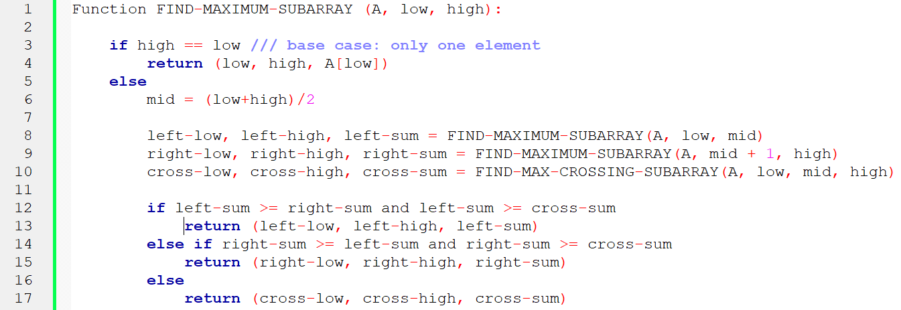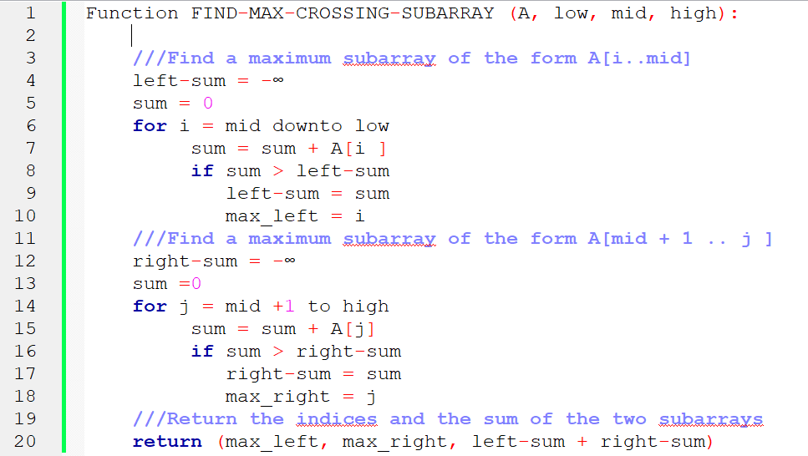

## 11. Longest common prefix of n strings

|  |  |
| --- | --- |
| **Sample Input** | **Sample Output** |
| 3  Algolab  Algorithms  Algeria | Alg |
| 4  Algolab  Algorithms  Algeria  UIU | No common prefix |

## 12. Closest pair of points

Ref: <https://www.cs.princeton.edu/~wayne/kleinberg-tardos/pearson/05DivideAndConquer.pdf> 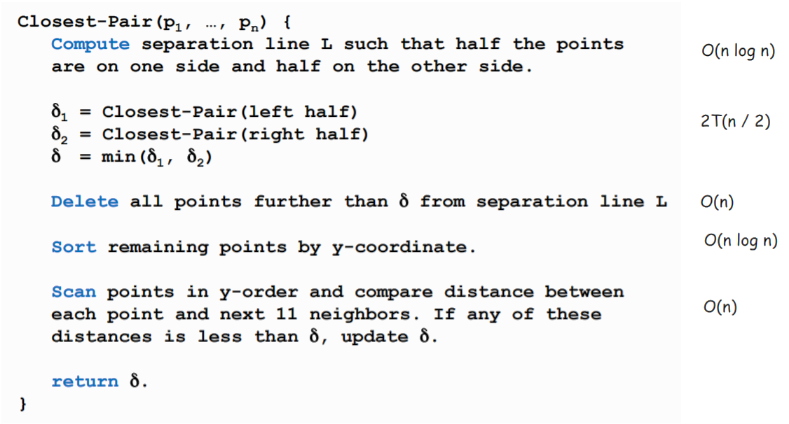

#### Running time:

$$T\left(n\right)≤2T\left(\frac{n}{2}\right)+O\left(n\log{n}\right) T(n) = O(n\log^{2}{n})$$

#### Can we achieve $O(n log n)$?

Yes. Don't sort points in strip from scratch each time.

* Each recursive returns two lists: all points sorted by y coordinate, and all points sorted by x coordinate.
* Sort by merging two pre-sorted lists.

$T\left(n\right)≤2T\left(\frac{n}{2}\right)+O\left(n\right) T(n)=O(n\log{n})$

## 13. More practice problems

<https://leetcode.com/tag/divide-and-conquer/>

# Reference:

* Slides of Dr. Md. Abul Kashem Mia, Professor, CSE Dept, BUET